|  |  |  |  |  |
| --- | --- | --- | --- | --- |
| Confluence SAML Configuration using Built in plugin |  |  |  |  |

SAML Configuration using Confluence Built in tool

Table of Contents

1. Introduction 3
2. SAML Configuration 3
3. Creation of Login Page 4
4. Configuring changes confluence server 6
5. Redirecting to multi login page when user logged out from confluence. 6

**Revision History**

|  |  |  |  |
| --- | --- | --- | --- |
| **Version** | **Date** | **Author** | **Reason for Change** |
| 1.0 | 13th July 2018 | Ravi S Balusu | Draft |
|  |  |  |  |
|  |  |  |  |
|  |  |  |  |
|  |  |  |  |
|  |  |  |  |
|  |  |  |  |
|  |  |  |  |

# Introduction

The purpose of this document is to provide guidance for configuration of SAML using Jira built in plugin.

Atlassian integrated the SAML built for Jira software Data center version starting from 7.5.4 version.  
Team who are using the Jira 7.5.4. version or more can easily integrate the SAML and no need to buy the vendor SAML plugins.

The following page need to be changed

1. seraph-config.xml

# SAML Configuration

1. Please send the ACS and entity ID information to Global pass team,the team will create and send the meta data
2. Once GP team create the ACS and entity Id and configure the same Jira
3. Login to Jira and select the SAML authentication (system->Security->SAML Authentication
4. Configure the values as shown in below screen

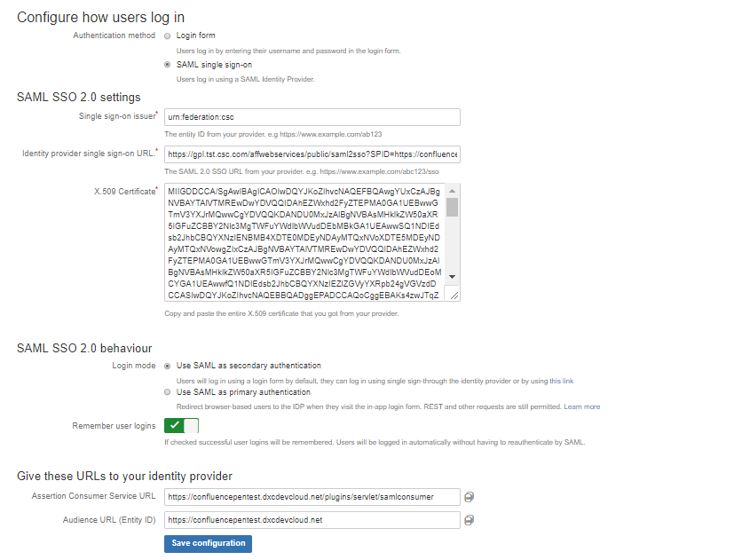

# Creation of Login Page

Devcloud is using both DXC internal & external users. Internal users will login through DXC global pass and external users will login through user id & password. We need to create a separate login page and provide the both options. When you browse the confluence.csc.com , this page will be loaded and user can select one of the login option. i.e DXC Global Pass or user Id & password.

Stop the confluence server and make the below changes  
Command : ./stop-confluence.sh from \atlassian\confluence\bin

Create new page called loginpageoption.vm and copy the below code and save it in below path in confluence tomcat sever.

The page looks like below

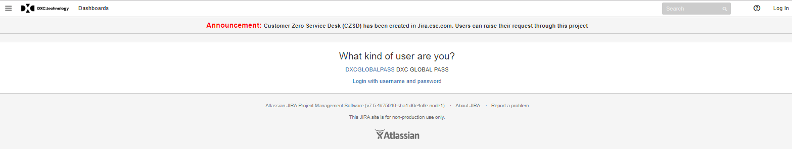

Path : /opt/atlassian/confluence/confluence/

|  |
| --- |
| #* @vtlvariable name="action" type="com.atlassian.confluence.user.actions.LoginAction" *#  #macro (errorBlock $msg)  <div class="error" tabindex="0"><p>$msg</p></div>  #end  #set($showSignup = $action.isShowSignUp())  <html>  <head>  #requireResource("confluence.web.resources:master-styles")  #requireResource("confluence.web.resources:login")  #requireResource("confluence.web.resources:aui-forms")  #requireResource("com.atlassian.confluence.plugins.confluence-scriptsfinished-plugin:scriptsfinished")  </head>  <body>  <section id="content" role="main">  <div class="aui-page-panel">  <div class="aui-page-panel-inner" >  <section class="aui-page-panel-content">  <div class="form-body"> <center>  <h1>What kind of user are you?</h1>  <p>  <a href="https://confluencepentest.dxcdevcloud.net/plugins/servlet/external-login">DXCGLOBALPASS</a> DXC GLOBAL PASS  </p>  <p>  <a href="https://confluencepentest.dxcdevcloud.net/login.action?nosso&os_destination=%2F">Login with username and password</a>  </p> </center>  </div>  </section>  </div>  </div>  </section>  </body>  </html> |

# Configuring changes confluence server

After creating the custom login page we need to add this page to **seraph-config.xml**  and the file is available in the following location. When you enter the <https://cofluence.csc.com> and it will take you to multi authentication page.

: /opt/atlassian/jira/atlassian-jira/WEB-INF/classes

Open the file make below changes and save

|  |
| --- |
| <init-param>  <param-name>login.url</param-name>  <!-- <param-value>/login.action?os_destination=${originalurl}&amp;permissionViolation=true</param-value>-->  <!--<param-value>/login.action?os_destination=loginpageoption.vm&amp;permissionViolation=true</param-value>-->  <param-value>/loginpageoption.vm</param-value>  </init-param>  <init-param>  <param-name>link.login.url</param-name>  <!-- <param-value>/login.action</param-value>-->  <param-value>/loginpageoption.vm</param-value>  </init-param> |

# Redirecting to multi login page when user logged out from confluence.

|  |
| --- |
| <script>  if(window.location.href.indexOf(contextPath+"/login.action?logout=true")!=-1)  {  window.location = contextPath+"/loginpageoption.vm"  }  </script> |